**PRACTICAL #8**



**#1 Retrieve the list of highest amount in EACH company.**



**#2 Retrieve the company with highest amount such that amount should be greater than 50000.**



**#3 Arrange identical companies in groups and display the full table.**



**#4 Retrieve the record such that the amount should be in decreasing order.**



**#5 List the names of company with their count.**



**#6 Find the total amount in each city.**



**#7 Find the total amount in each city where amount should be greater than 40000.**



**#8 List the minimum and maximum amount of each company.**



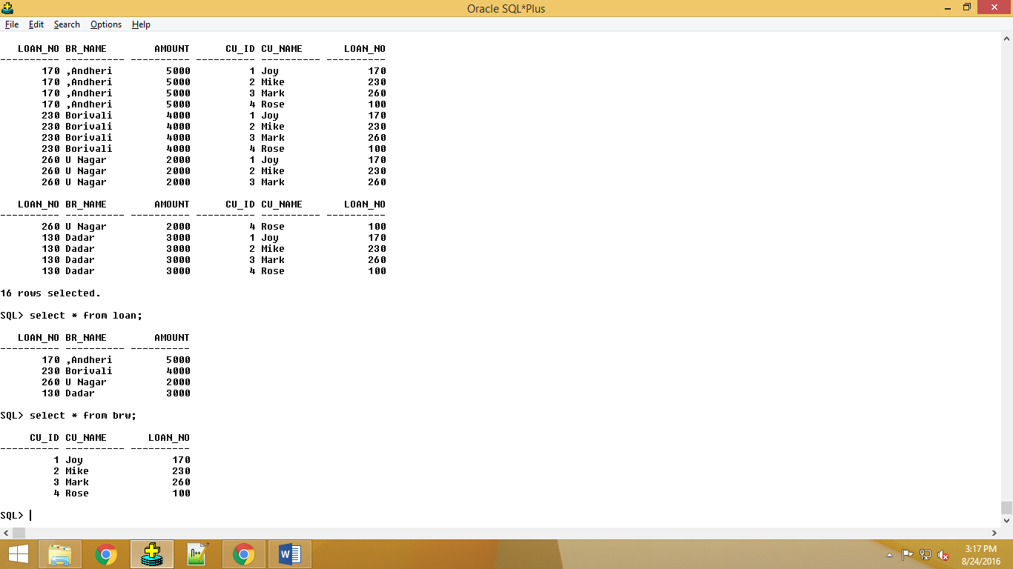

**#1 Perform Inner Join**

**select * from loan**

**inner join brw on**

**loan.loan_no=brw.loan_no;**

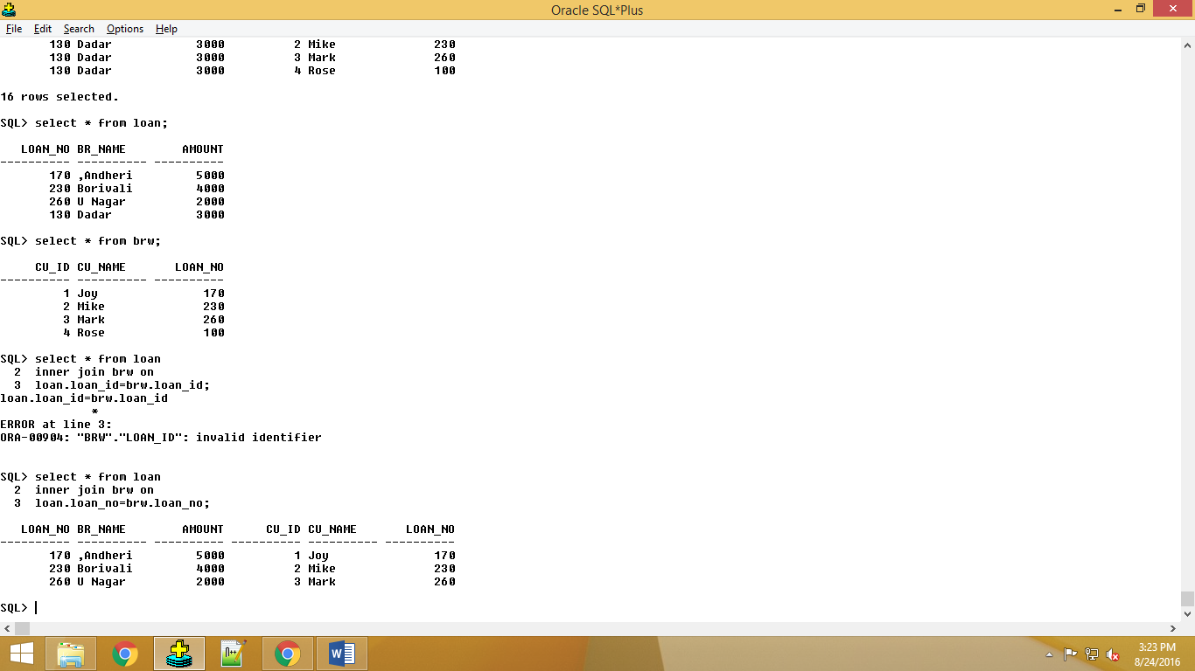

**#2 Natural Inner Join**

**select * from loan**

**natural inner join brw;**

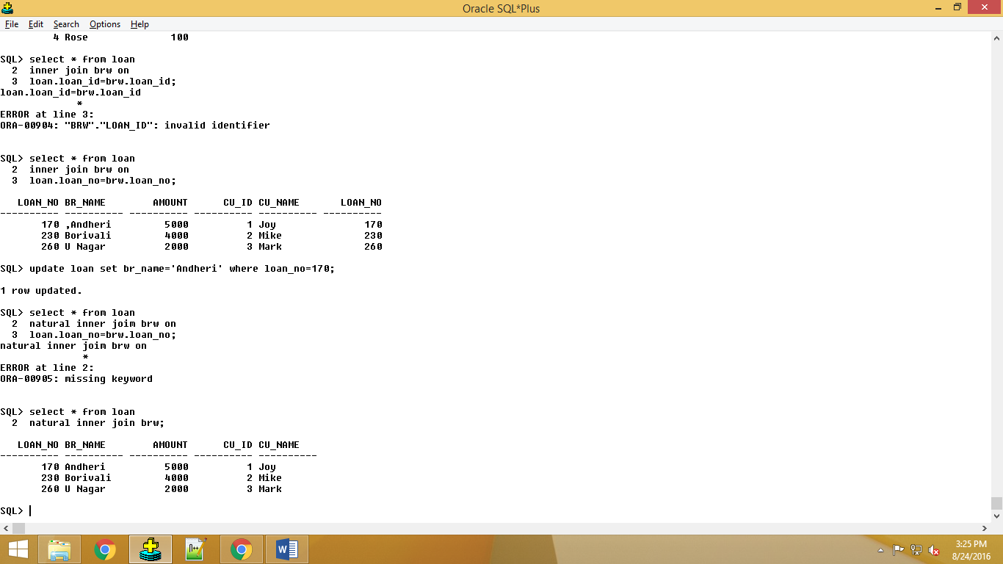

**#3 Left Outer Join**

**select * from loan**

**left outer join brw on**

**loan.loan_no=brw.loan_no;**

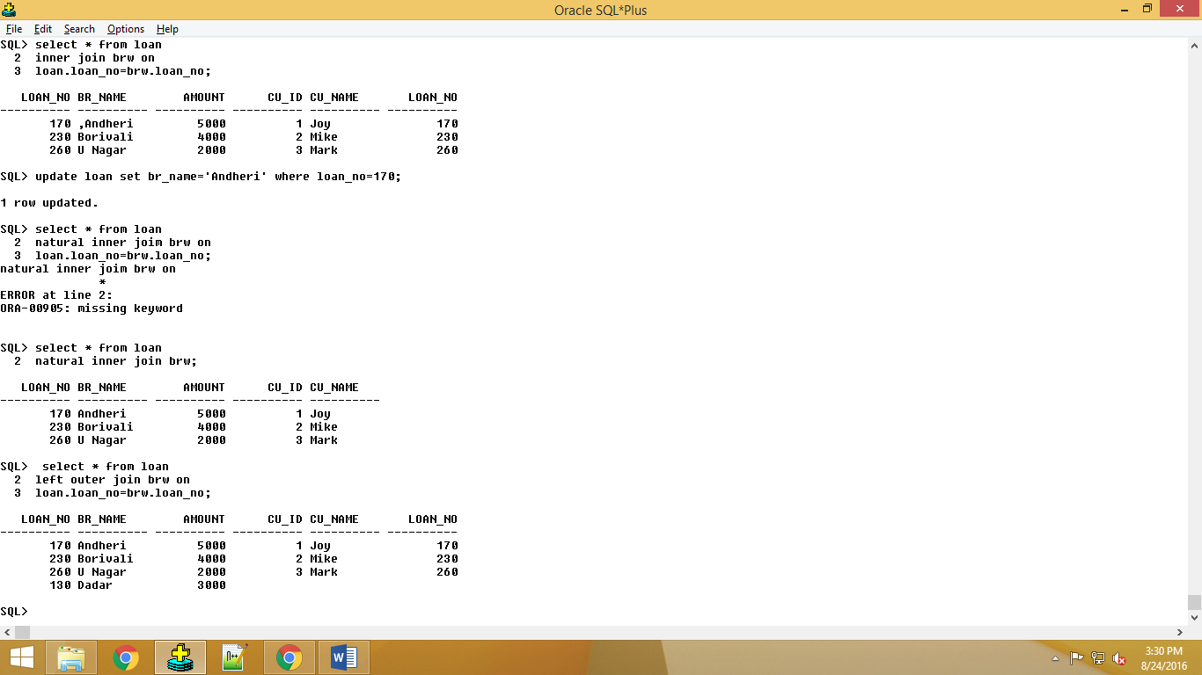

**#4 Right Outer Join**

**select * from loan**

**right outer join brw on**

**loan.loan_no=brw.loan_no;**

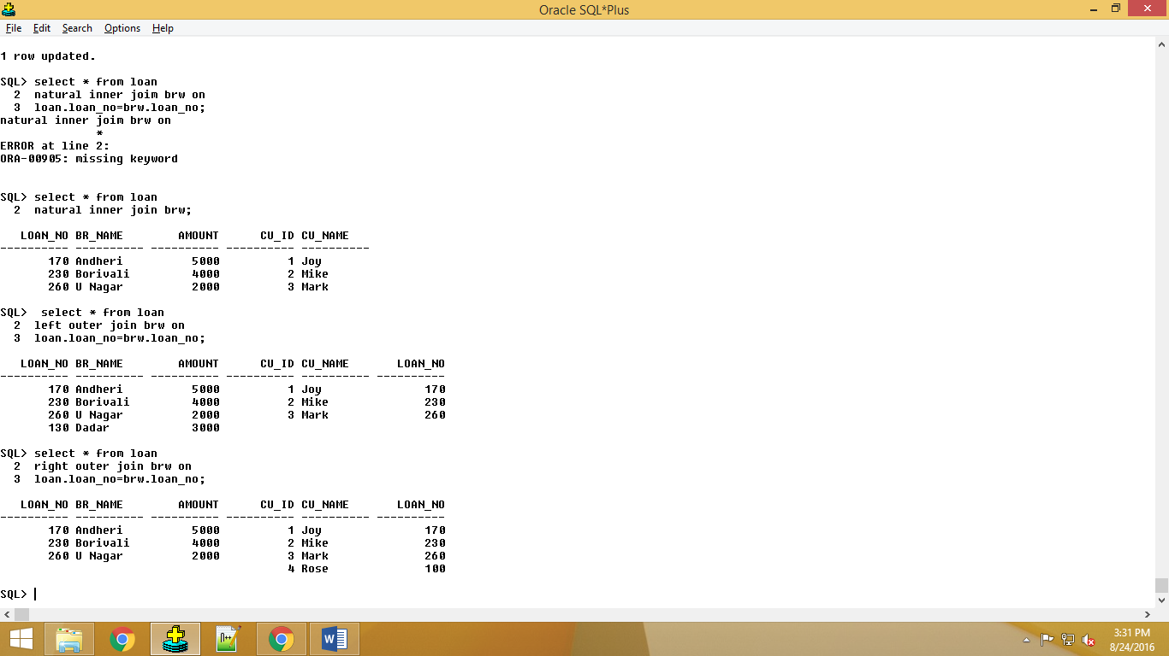

**#5 Create a report with customer name and borrower name without any null value**

**select cu_name, br_name from brw**

**inner join loan on**

**brw.loan_no=loan.loan_no;**

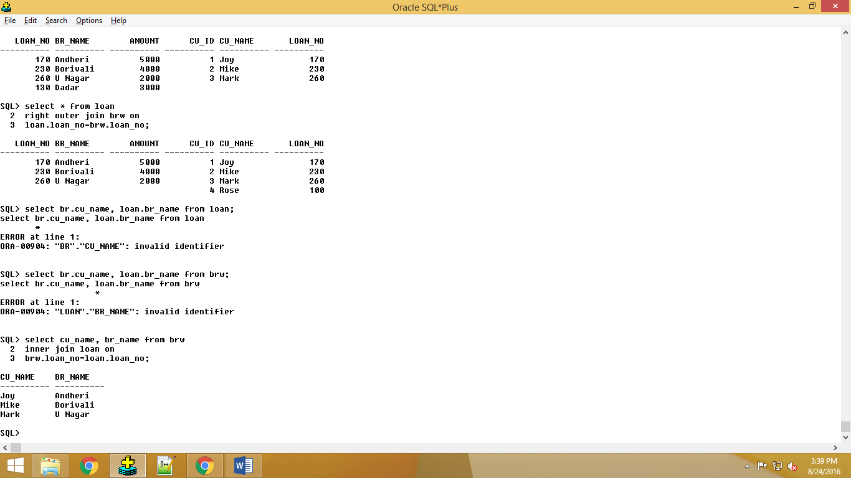

**#6 Create a report with customer name and amount with allowing null values for amount.**

**select brw.cu_name, loan.amount from brw**

**left outer join loan on**

**brw.loan_no=loan.loan_no;**



**#7 Create a report with customer id and amount with allowing null values in customer id.**

**select l.amount, b.cu_id from loan l**

**left outer join brw b**

**on l.loan_no=b.loan_no;**

